MP6 Performance Evaluation
Heath Gerrald

Part 1) Finding the shortest path on graph 2, I found the following data. This data supports that my implementation does follow a O(n^2) complexity in that every time the nodes N are doubled (besides low values of N) the output is quadrupled. In jobs from 500 to 1000, 1000 to 2000, and 10,000 to 20,000, the output time is 4x the half. To prove that this ratio should be 4, take the examples of 8 and 16. 8^2 = 64, and 16^2 = 256, where 256 / 64 = 4. In further analysis, you can see from my graph below that my data follows a n^2 trend.

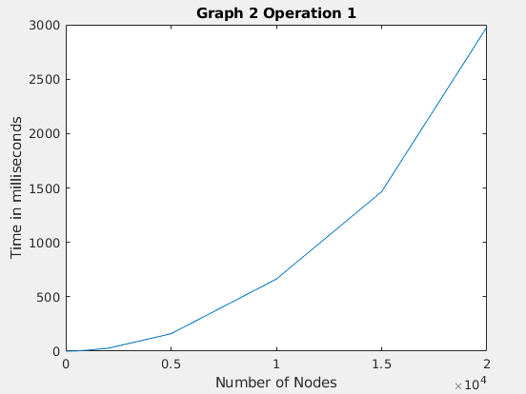

b) Running the same test with the random graph construction and adjacent vertices equal to 20 (-a 20) I collected the following data. These times follow the same pattern as those above, showing that my implementation with random graphs is still O(n^2). The graph illustrating this data is shown below.

* the top input is 100 nodes
instead of 10 to keep adjacent vertices similar for all tests

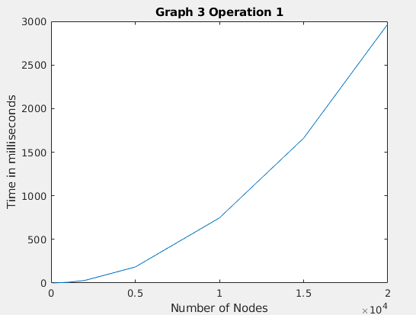

2) My finding network diameter implementation has an O(n^3) complexity. I came to this conclusion since every time the number of nodes are doubled, the output time is 8x the half. With an O(n^2) algorithm, it would be 4x the half. For each jump below where the nodes are doubled, the time typically increases by 8 fold.

3) In experimenting with node density for random graphs, I compared how the adjacent vertices parameter affects the probability that the graph will be connected. My results were as expected – when there are few adjacent vertices there is a less likely chance the graph will be connected.

4) Below is the data recorded from 5 trials of running multiple link-disjoint paths and each shows there are N-1 paths. In each trial the source node was N-1 and destination node was 0.

When running the same test but changing the number of adjacent vertices parameter, I discovered that increasing the number of adjacent vertices increases the number of possible paths. This result was as expected.

